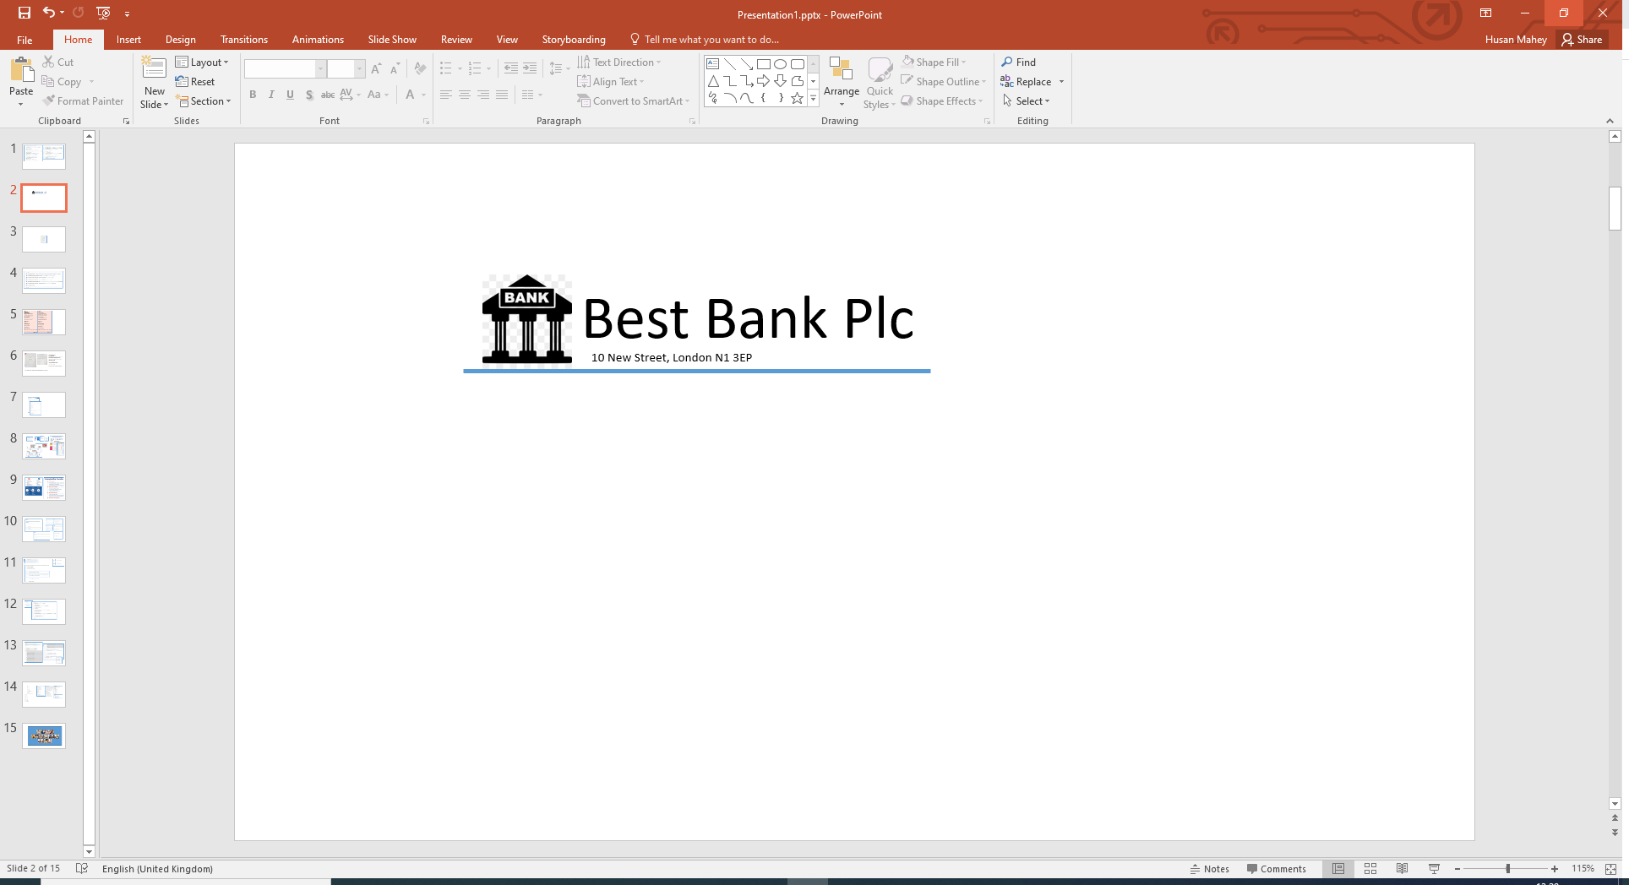

Miss Sarah Mchughes

73 Parkfield Rd

Parwich

Derbyshire

DE6 1QN

Our Ref: Q300

Dear Sarah,

Congratulations! Based on the information provided by you, we are pleased to inform you that you have been pre-approved for your recent loan application.

**Loan Details**

Amount: £ 7,500.00

Term: 48 months

Interest Rate (APR): 3.00%

Total Payable: £ 7,961.76

Monthly Payment: £ 165.87